THE ENGLISH LANGUAGE UNIT YANBU UNIVERSITY COLLEGE YANBU INDUSTRIAL CITY SAUDI ARABIA | 
Final Project
Academic Year 2019 – 20G (1440 – 41 H) Fall Semester 191

ENGL 211- Business Report Writing

Submission: December 8, 2019

Student's Name: Murtaja Mohammed Al-rajab

Student’s ID:

3 | 7 | 2 | 0 | 2 | 3 | 9

FOR INSTRUCTOR'S USE ONLY
Section: 2
_
General Instructions:
Follow the Instruction Given in Each Section of this Project + Class Instructions

SIGNATURE:
MARKED BY:
MARK AWARDED:
TOTAL MARK: 40

Some Parameters about Producing Pulp/Paper in the Green Valley City

Name: ID:
Department: Specialty: College: Date:

Font: Times New Roman Size: 12
Space between lines: 1

Introduction

(2 points)

The aim of the report

The aim of the report is to identify as well as analyze various metrics, that might be considerably significant to impact the volume and rate of producing paper or pulp in the Green Valley City Company.

Goal of the report

- To identify the internal components that might influence the production of paper in Green Valley City Company

- To identify the external elements that might influence the production of paper in Green Valley City Company

- To analyze the manner in which both external and internal components can be managed to enhance efficiency and effectiveness in the production of pulp in Green Valley City Company
Types of data used

The type of data used in this report is secondary. The data was collected from Green Valley City Company’s website, books, periodicals, newspapers, journal articles. The information concerning the company’s level of production from 2000-2015, and projection from 2020-2035.Additioinally, information concerning the organization market share both local and internationally was collected and tabulated

Types of diagrams to be analyzed
In this the diagram of a pulp or papermaking process will be analyzed. Also, the information collected and tabulated will be used to draw graphs and each type of graph will be analyzed

Results and Discussion

Basic Process Diagram (12 Points)
Paper plays a crucial role in our economy. Papers are usually produced with pulp, which is a commodity that is eco-friendly. The paper is often produced through the following basic process:
- Cutting trees and taking them to the saw mills
- Pulping steps is done to clean and separate the fibers
- Refining will be done after the pulping process
- Dilution is carried out to create the thin mixture of fibers
- The formation of the fibers on the thin screened
- Pressurization to enhance the density of the materials
- Drying to remove the material density

Steps Involved in paper and pulp making

Material preparation
As indicated in figure 1 below wood is taken to the saw mill in various forms. In the saw mills they are cut and prepared as bolts or short logs of the round wood materials. Then the saw merchants take them for chipping where wood is debarked through tumbling in the huge steel drums as well as there is application wash water. The debarked short logs are chipped in the chipping machine in case the pulping or papermaking process requires chemical digestion (Bajpai, 2015). Then the chips are usually screened for size washed or cleaned and stored temporarily for further processing.
Fiber separation

In this stage various pulping techniques will be used. The chips are put in a digester and appropriate digesting chemicals are added in the kraft chemical pulping (Bajpai, 2015). The digester then digests the chips through the use of steam at various temperatures to help in fiber separation as well as partially dissolve extractives such as lignin. After the digestion process the cooked pulp is then put in the pressure vessel to tube off volatile materials and steam. The debarked bolts are discharged into the grinder and the chemical pulp and refiner pulp are generated by the chipsPuneet,2012). In the next stage after the refining process the pulp is cleaned and screened and, in the process, water is eliminated in the preparation for the production of paper.
Bleaching process
The raw pulp usually contains considerable amount of lignin as well as other forms of discoloration. Therefore, the pulp should be bleached to create white or light-colored papers (Bajpai, 2015) The fibers are often delignified further though additional lignin solubilization from cellulose by oxidation and chlorination. These usually includes hydrogen peroxide, oxygen, sodium hypochlorite, chlorine gas, and chlorine oxide.

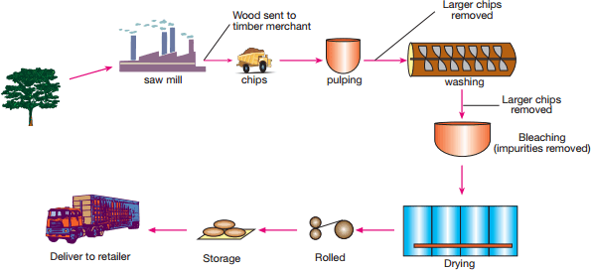

Figure 1: Paper making process
  - Basic Parameters about Paper Pulp Production (15 points)

    - Previous and Projected Parameters of Pulp Production (2000 to 2035)
Year | Production in  Tons (in million) | Exports in  Tons (in million) | Local Sales in  Tons (in million) | Storage (in million) | Percentages (of exports) | Percentages  (of local sales)
2000 | 80 | 2 | 65 | 13 | 2.5% | 81.25%
2005 | 86 | 2 | 44 | 40 | 2.33% | 51.16%
2010 | 89 | 8 | 8 | 73 | 9% | 9%
2015 | 120 | 8 | 102 | 10 | 6.66% | 85%
2020 | 240 | 12 | 230 | 0 | 5% | 95%
2025 | 280 | 20 | 282 | 0 | 7.14% | 93.57%
2030 | 340 | 20 | 320 | 0 | 5.88% | 94.12%
2035 | 550 | 50 | 500 | 0 | 9.1% | 90.9%

Table 1
The table 1 above contains the projected and previous parameters of the production of pulp production .In 2000 the production is 80 million tones and exports and local sales were 2 million tones and 65 million tones respectively and the storage was 13 million tones .The production level has a positive trend since from 2005 to 2015 it increased from 86 million tones to 120 million tones. Additionally , the market both internationally and locally decreased from 2000-2010 but increased from 2010-2015.And the projections indicates that 2020,2025,2030, and 2035 there will unsold stock .
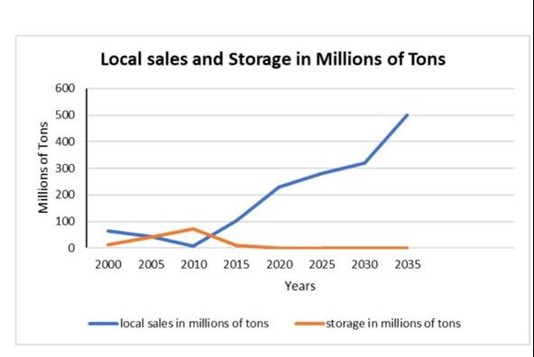

Graph 1: Local sales and storage
The graph indicates that in 2012 the amount of local sales and storage was the sale. Also, from 2000 to 2010 there was a decline in local sales and but there was an increase in the storage amount. However, from 2010 to 2035 the volume of local sales is not bad. Also, there is a const rate of diminishing for the storage volume. Hence, the projections indicate that there will large sale returns.

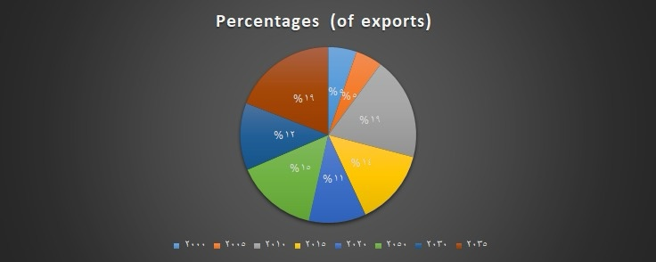
The pie chart: Percentage of exports
The pie chart shows that in 2000 and 2005 occupies only 2.5% and 2.33% respectively and 2010 occupies 9% and it is projected in 2035 the exports sales will be 9.1%.

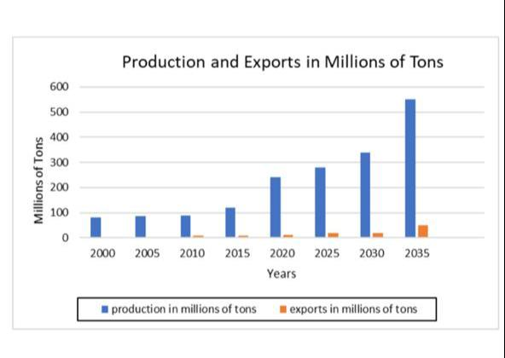

Graph2. Production and exports

Conclusion

Pulp production chemically or mechanically. The pulp is usually breached and further manufactured or processed depending on grade and type of paper to be produced. However, the process is expensive since is capital intensive and can result in environmental pollution because too much use of wood materials may lead to deforestation

References
Bajpai, P. (2015). Green Chemistry and Sustainability in Pulp and Paper Industry. doi:10.1007/978-3-319-18744-0_2
Puneet, A. (2012). Use of laccase in pulp and paper industry. Biotechnology progress, 28(1), 21-32.

